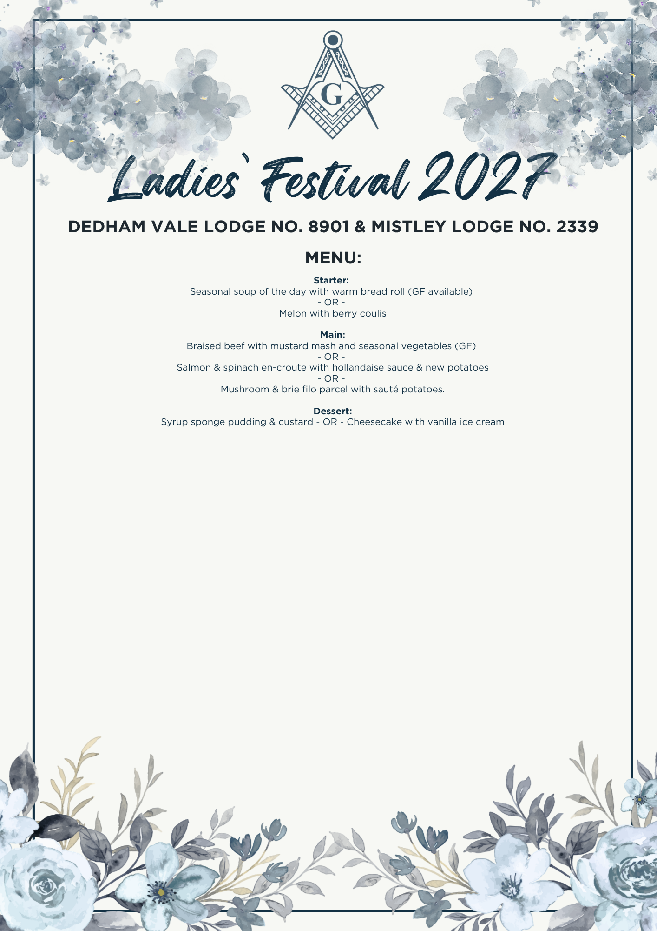

NAME | Starter | Main | Dessert | Dietary Requirements?
Fred Bloggs | i.e. Soup | i.e. Mushroom | i.e. Sponge | i.e. gluten free
Please return with £55 per ticket or £30 per ticket deposit by 30th September (full payment by 31st December 2026) and menu choices to:
John Parker (jpkp@manningtreemasons.org) - Mistley Masonic Lodge No2339 Festival, 20-22-69, 90555606
Or Richard Clarke (richardlclarke@aol.com) - Dedham Vale Festival Account, 60-06-06, 32430019

